**Angular Hooks**

ng serve –o –port 4209

A component in Angular has a life-cycle, a number of different phases it goes through from birth to death.

We can hook into those different phases to get some pretty fine grained control of our application.

To do this we add some specific methods to our component class which get called during each of these life-cycle phases, we call those methods *hooks*.

The hooks are executed in this order:

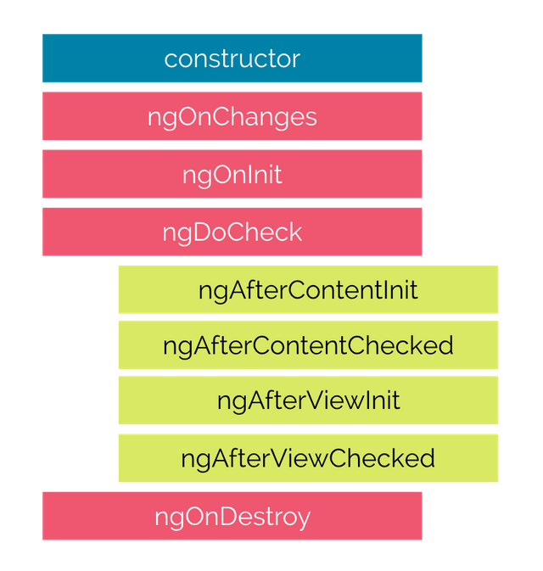

These phases are broadly split up into phases that are linked to the component itself and phases that are linked to the *children* of that component.

Hooks for the component

**constructor**

This is invoked when Angular creates a component or directive by calling new on the class.

**ngOnChanges**

Invoked **every** time there is a change in one of th *input* properties of the component.

**ngOnInit**

Invoked when given component has been initialized.  
This hook is only called **once** after the first ngOnChanges

**ngDoCheck**

Invoked when the change detector of the given component is invoked. It allows us to implement our own change detection algorithm for the given component.

Important

ngDoCheck and ngOnChanges should not be implemented together on the same component.

Note

We will cover this hook in more detail in the *Advanced Components* section at the end of this course.

**ngOnDestroy**

This method will be invoked just before Angular destroys the component.  
Use this hook to unsubscribe observables and detach event handlers to avoid memory leaks.

Hooks for the components children

These hooks are only called for components and not directives.

Note

We will cover the difference between Components and Directives in the next section.

**ngAfterContentInit**

Invoked *after* Angular performs any content projection into the components view (see the previous lecture on *Content Projection* for more info).

**ngAfterContentChecked**

Invoked each time the content of the given component has been checked by the change detection mechanism of Angular.

**ngAfterViewInit**

Invoked when the component’s view has been fully initialized.

**ngAfterViewChecked**

Invoked each time the view of the given component has been checked by the change detection mechanism of Angular.

## **Interfaces**

In the sample code so far we are just defining the hook functions directly on the class, but we can take advantage of a feature of TypeScript, interfaces, and be more explicit regarding our intentions.

Each of these lifecycle hooks has an associated typescript interface of the same name but without the ng prefix. So ngOnChanges has an interface called OnChanges.

Each interface defines just one hook, by making a class implement an interface we are saying we expect the class to have implemented that member function, if it doesn’t then TypeScript should throw an error.

Adding the interfaces for our life-cycle hooks to our JokeComponent class would look something like so:

import {

OnChanges,

OnInit,

DoCheck,

AfterContentInit,

AfterContentChecked,

AfterViewInit,

AfterViewChecked,

OnDestroy

} from '@angular/core';

class JokeComponent implements

OnChanges,

OnInit,

DoCheck,

AfterContentInit,

AfterContentChecked,

AfterViewInit,

AfterViewChecked,

OnDestroy {

...

}

## **Adding hooks**

In order to demonstrate how the hooks work we’ll adjust the joke application we’ve been working with so far.

Firstly lets change the JokeComponent so it hooks into all the phases.

All we need to do is to add functions to the component class matching the hook names above, like so:

class JokeComponent {

@Input('joke') data: Joke;

constructor() {

console.log(`new - data is ${this.data}`);

}

ngOnChanges() {

console.log(`ngOnChanges - data is ${this.data}`);

}

ngOnInit() {

console.log(`ngOnInit - data is ${this.data}`);

}

ngDoCheck() {

console.log("ngDoCheck")

}

ngAfterContentInit() {

console.log("ngAfterContentInit");

}

ngAfterContentChecked() {

console.log("ngAfterContentChecked");

}

ngAfterViewInit() {

console.log("ngAfterViewInit");

}

ngAfterViewChecked() {

console.log("ngAfterViewChecked");

}

ngOnDestroy() {

console.log("ngOnDestroy");

}

}

@Component({

selector: 'joke-list',

template: `

<joke *ngFor="let j of jokes" [joke]="j">

<span class="setup">{{ j.setup }} ?</span>

<h1 class="punchline">{{ j.punchline }}</h1>

</joke>

<button type="button"

class="btn btn-success"

(click)="addJoke()">Add Joke

</button>

<button type="button"

class="btn btn-danger"

(click)="deleteJoke()">Clear Jokes

</button>

`

})

class JokeListComponent {

jokes: Joke[] = [];

addJoke() {

this.jokes.unshift(new Joke("What did the cheese say when it looked in the mirror", "Hello-me (Halloumi)"));

}

deleteJoke() {

this.jokes = []

}

}

## **Detecting what has changed**

We can actually tap into the exact changes to the input properties by examining the first param to the ngOnChanges function, which we typically call changes.

The type of changes is a map of the input property name to an instance of SimpleChange:

class SimpleChange {

constructor(previousValue: any, currentValue: any)

previousValue : any

currentValue : any

isFirstChange() : boolean

}

Using the above we can find out in our ngOnChanges function which input properties changed (if we have more than one) and also what the previous and current values are.

We change our ngOnChanges function to take the changes argument and loop through it to print out the SimpleChange.currentValue and previousValue.

ngOnChanges(changes: SimpleChanges) {

console.log(`ngOnChanges - data is ${this.data}`);

for (let key in changes) {

console.log(`${key} changed.

Current: ${changes[key].currentValue}.

Previous: ${changes[key].previousValue}`);

}

}

## **Listing**

import { platformBrowserDynamic } from "@angular/platform-browser-dynamic";

import {

Component,

NgModule,

Input,

Output,

EventEmitter,

ViewEncapsulation,

SimpleChanges,

OnChanges,

OnInit,

DoCheck,

AfterContentInit,

AfterContentChecked,

AfterViewInit,

AfterViewChecked,

OnDestroy

} from "@angular/core";

import { BrowserModule } from "@angular/platform-browser";

class Joke {

public setup: string;

public punchline: string;

public hide: boolean;

constructor(setup: string, punchline: string) {

this.setup = setup;

this.punchline = punchline;

this.hide = true;

}

toggle() {

this.hide = !this.hide;

}

}

@Component({

selector: "joke",

template: `

<div class="card card-block">

<h4 class="card-title">

<ng-content select=".setup"></ng-content>

</h4>

<p class="card-text"

[hidden]="data.hide">

<ng-content select=".punchline"></ng-content>

</p>

<a class="btn btn-primary"

(click)="data.toggle()">Tell Me

</a>

</div>

`

})

class JokeComponent

implements

OnChanges,

OnInit,

DoCheck,

AfterContentInit,

AfterContentChecked,

AfterViewInit,

AfterViewChecked,

OnDestroy {

@Input("joke") data: Joke;

constructor() {

console.log(`new - data is ${this.data}`);

}

ngOnChanges(changes: SimpleChanges) {

console.log(`ngOnChanges - data is ${this.data}`);

for (let key in changes) {

console.log(`${key} changed.

Current: ${changes[key].currentValue}.

Previous: ${changes[key].previousValue}`);

}

}

ngOnInit() {

console.log(`ngOnInit - data is ${this.data}`);

}

ngDoCheck() {

console.log("ngDoCheck");

}

ngAfterContentInit() {

console.log("ngAfterContentInit");

}

ngAfterContentChecked() {

console.log("ngAfterContentChecked");

}

ngAfterViewInit() {

console.log("ngAfterViewInit");

}

ngAfterViewChecked() {

console.log("ngAfterViewChecked");

}

ngOnDestroy() {

console.log("ngOnDestroy");

}

}

@Component({

selector: "joke-list",

template: `

<joke *ngFor="let j of jokes" [joke]="j">

<span class="setup">{{ j.setup }}?</span>

<h1 class="punchline">{{ j.punchline }}</h1>

</joke>

<button type="button"

class="btn btn-success"

(click)="addJoke()">Add Joke

</button>

<button type="button"

class="btn btn-danger"

(click)="deleteJoke()">Clear Jokes

</button>

`

})

class JokeListComponent {

jokes: Joke[] = [];

addJoke() {

this.jokes.unshift(

new Joke(

"What did the cheese say when it looked in the mirror",

"Hello-me (Halloumi)"

)

);

}

deleteJoke() {

this.jokes = [];

}

}

@Component({

selector: "app",

template: `

<joke-list></joke-list>

`

})

class AppComponent {}

@NgModule({

imports: [BrowserModule],

declarations: [AppComponent, JokeComponent, JokeListComponent],

bootstrap: [AppComponent]

})

export class AppModule {}

platformBrowserDynamic().bootstrapModule(AppModule);

Constructor : for initialization

ngInIt : load data or fetch data from service after page init

DoCheck: keep validating the state of data (either any component is modified)